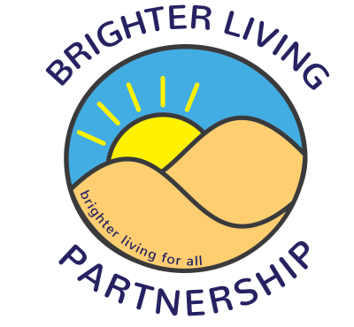

Brighter Living Men’s Group
April – June 2023, Fridays 1-3pm at Southport Community Centre unless otherwise stated
Call 01704 517810 for details

7th April – Bank holiday (no group)
14th April – Les Dodd snooker & pool, Princes Street
21st April – Scarisbrick Bowling Club, 1a Falkland Road
28th April – Liverpool World Museum trip – see Katy for details
5th May – Yoga, Southport Community Centre
12th May – Hesketh Park – meet at the cafe
19th May – mini golf – meet at the carousel by Funland
26th May – Follow up session from World Museum trip, Southport Community centre
2nd June – Yoga, Southport Community Centre
9th June – Botanic Gardens – meet at main entrance
16th June – Les Dodd snooker & pool, Princes Street
23rd June – Scarisbrick Bowling Club, 1a Falkland Road
30th June – Yoga, Southport Community Centre

