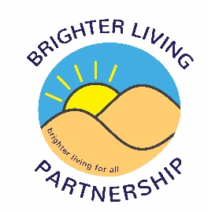

Brighter Living Partnership – Trustee expression of interest form

Brighter Living Partnership is looking to recruit a number of people to strengthen our board of Trustees as the organisation looks to further develop and to also aid in the recovery from the COVID pandemic.

Brighter Living Partnership is a registered charity and a company limited by guarantee, it was established in 2000. Based in Southport and predominantly covering north Sefton, the organisation runs a range of projects that support local people to improve their health and wellbeing.

If you are interested in potentially becoming a trustee of Brighter Living Partnership then please complete the information below.

Personal Details

Name (including title)

Home Address
Contact Number
Email

Work/volunteer history

Please provide a brief summary of any paid or unpaid roles which you feel are relevant to work of Brighter Living Partnership
Please include details such as Job Title, Employer, and a summary of your main duties and responsibilities | Dates

Personal statement

Please explain why you are interested in becoming a trustee with BLP and what skills and knowledge you will bring to the role.

Once complete please return this expression of interest form to Matty Smith via matty.smith@brighterliving.org.uk

