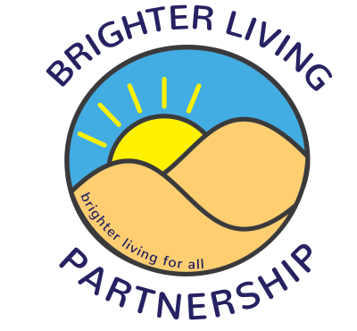

Brighter Living Men’s Group
July - September 2023, Fridays 1-3pm
Call 01704 517810 for details

21st July – Les Dodd’s snooker and pool, Princes Street
28th July – Hesketh Park, meet at the café
4th August – Games day, Southport Community Centre
11th August – Botanic Gardens, meet at entrance
18th August – BBQ, Southport Community Centre
25th August – Les Dodd’s snooker and pool, Princes Street
1st September – Quiz, Southport Community Centre
8th September – Mini golf, meet by carousel
15th September – The Atkinson, meet at the café
22nd September – Les Dodd’s snooker and pool, Princes Street
29th September – Film day, Southport Community centre

