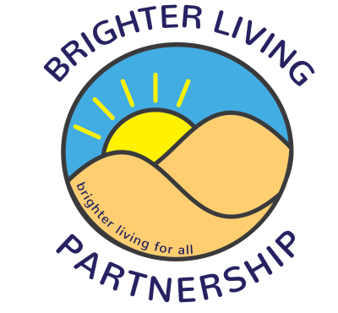

Brighter Living men’s Group
July - September 2022, Fridays 1-3pm at Southport Community Centre unless otherwise stated

1st July - Snooker
8th July – Merseyside Police talk on scams and fraud
15th July – Angela’s IOM talk part 2
22nd July – Shared Reading
29th July – Scarisbrick Bowling Club
5th August – Mini Golf
12th August – Scarisbrick Bowling Club
19th August – Shared Reading
26th August – Mindfulness Relaxation Session
2nd September – Southport Pier
9th September – Scarisbrick Bowling Club
16th September – Card & Board Games
23rd September – Shared Reading
30th September – Ten Pin Bowling

